**Online Blood bank Management System**

**Abstract -** The Online Blood Banking management system is an attempt to reduce the collateral processes related to obtaining and donating blood for blood transfusion. The website users can get information on the availability of blood types in various blood banks around the required radius. This gives a more centralized system. Almost every surgery and blood transfusion require the use of blood. Although this system is not much time consuming and error will be low for appropriate blood types however there are still issues such as blood shortages and non-availability. Individuals will be discouraged from donating blood until a proper blood management system is put in place. This project also focus on the future scope with upgradation of this blood management system. In the new world information and communication is more productive and reliable like where person can order things dresses, food etc. online within the surely of getting the item within the given date , where person can book the holiday ticket online, where person can book his/her hotel staying online, then in a life and death situation blood bank management system plays an important role for people for accurate blood groups and minimal errors , just in one click. Today everything is almost available online. This gives the people a privilege to go cost effective , get more option , easy to access from your comfort zone and for fast services.

# 1.INTRODUCTION

Blood is a totally intrinsic a part of the healthcare machine. Blood as an entire is donated voluntarily which later may be used for sufferers or the guidance of therapeutic products. Various additives of blood may be separated and used later as in keeping with the need. The requirement of blood in hospitals may also rise up at any second and therefore it is required to make certain the provision of blood in blood banks all of the time. Blood banks are certain areas equipped with experts and kinds of equipment that assist collect, shop and maintain blood. The requirement of blood in India is sort of thirteen crore units in keeping with year. But there's a complete mismatch withinside the blood accumulated and the blood required. Haphazard control of blood results in diverse problems like non-availability of blood, scarcity of blood, and last-minute panic situations many of the those who require blood. The on-line blood financial institution control gadget can assist adjust the method of blood float and abolish the loopholes of the gadget. The number one intention of this task is to create a hassle-free revel in for the donors and receivers withinside the blood donation method. Since the internet site additionally collects records of customers consensually, who want to donate blood withinside the Future, a database of voluntary capacity donors is created and may be used for emergency functions for that reason saving lives

## 1.1 Proposed Project

The main purpose of this project is to connect various ends of the blood donation process and automate it. While easing the efforts taken for the blood searching/donating process the website is also is expected to make the process faster, easier, and reliable than normal traditional methods. The website provides a very easy user interface with various features that are need of the hour. Some of which include locating blood banks near your location, sharing the obtained location with a dedicated share button, providing you with directions to the desired blood bank with an integrated google map button, a direct hyperlink to the contact details of that particular blood bank, availability along with the number of units of every blood group. Real-time updating of units of blood available in the selected blood bank is one of the most prime features.

# Methodologies

## Blood bank Web Application

This Module Consist of element records of how utility works. The blood financial institution control machine is the web-primarily based totally on line utility with SMS in addition to Email alert characteristic diverse sharing alternatives thru social media packages and Blood financial institution locator. That applied the usage of HTML CSS PHP JavaScript and SQL for database.

In this Module the requests from receptors for the required blood organization are served.

The Blood donor can sign in at the machine and it will offer a donor identity entification at the crowning glory of registration thru Email service .if the fake request despatched to the blood financial institution the admin in addition to blood financial institution have complete rights to delete the request. In case If the request is despatched to blood financial institution for particular blood organization through consumer and his registration identity entification also generated however lamentably consumer won’t come, the machine robotically cancel his registration identity entification and replace blood financial institution facts through the usage of actual time updating The machine will tell to all of the applicable donors with the request. Blood financial institution can upload or cast off a donor from the machine. Also he can upload blood inventory to the applicable blood financial institution. Blood Bank Management machine has separate Admin panel.

## Database

In this system, database is used to record and manage the transactions of blood donations and blood issued. The main purpose of this system is to keep an organize records management of blood. Information such as Donor Details, Blood Collection, Screening, Component preparation, Blood storage, Blood request, Compatibility, Blood issue, Monthly statistics records are stored using database. It provides great help in the properly monitoring of blood available in the blood bank and for easy processing of blood request.

**Literature Review**

K.G.Prasanna.et.al(2020) projected an online blood bank management system that gives access to the user to request an organization to give them blood. Donors' and seekers' information can be stored in the centralized database that can be maintained by the system. Only registered users can access it. SQLite is used in this project. The outcomes revealed that the introduced project was applicable to enhance clients to enter the desired information through so much simplicity.

D.S. Kim. et.al (2007) describes the system based on the RFID and ubiquitous sensor network. The system helps to ensure an error-free blood transfusion process. This system is developed and demonstrated for the continuous report of blood packet temperature and tracking the location of blood bags. The LTS unit of the system was a useful way to track the location of moving blood banks and the time required of the medical staff was reduced. This system makes managing blood bags simple and reliable.

S. Sarath. et. al (2019) projected an online blood management System that helps people who need blood by giving them overall details regarding the

donors with the same blood and within their city. This project saves people the time of searching for blood. The outcome revealed that the introduced project was able to find people like donors and receivers from the same city.

Albert Mayan J .et .al (2016) an application developed for finding blood and donations for requesting blood. Any blood seeker would log in to the given application then using GIS the patient will get detail about the nearest blood donor. Also, any blood donor can add themselves for donating the blood then he will receive the notification related to the blood camp.

WijaiBoonyanusith.et.al (2010) developed a website that consists of information related to the bloodstock of a given specific area. It uses. PHP for designing a website and also uses my SQL for storage of the database. When any hospital requires blood then that hospital is required to fill in the data on the blood bank website then according to the required blood group the website will display the amount of bloodstock available at the different blood banks within a specific Geographic area. Then the hospital has to send a request to the blood bank for the blood, the blood bank will give them replies for providing the blood. The main objective of the system is to improve the efficiency of data communication within the supply chain to reduce response time for each demand request.

Adarsh N.et, al (2014) developed a system used for the effective management of blood banks based on RFID. The system reduces the number of transfusion errors the system by continuous track the inventory status of the blood bank in real-time and has crossed checks at various locations to ensure the correct blood transfusion process. The system becomes more efficient because the read time of RFID (0.001s) is far greater compared with barcodes (1s)

C.A Shankar. et, al (2014) defined Blood Bank Information System as an information management system that contributes to the management of donor records and blood bank. This application contains a User Login Screen, Blood Management, Menu Form, Blood Stock, Donor Management, Donor Registration, Blood Reservation, Donor Blood Test, Recipient Management, and Blood Reservation. Similarly, the researchers planned for the application to have hospital administrators, doctors, and blood bank receptionists as users. This system was designed to suit all types of blood banks. Once successful in the implementation of the application, it can be applied and rolled out in several blood banks.

R. Singh. et, al (2017) these researchers mentioned that a manual-based system can be waste of time, lead to error-prone results, consumes a lot of manpower, lacks data security, data retrieval requires a lot of time, reports consume a long time to produce, and there is less precise accuracy on the results. As such, by developing and implementing a web-based blood management information system, there was quick and timely access to donor records, and the system provided management with timely, confidential, and secured medical reports. There were three (3) users in the system, namely: Administrator, Donor, and Acceptor. Each user has been given a user ID and password to identify their identity. The said application was developed using ASP.NET, C#.NET, and using SQL Server 2000/2005 for the database. The research paper failed to mention the methods of research used.

G. Muddu Krishna .et, al (2016) proposed a short message services-based blood bank system, it consists of two modules a data processing module and a packet account module. The data processing module responds to the user request and the packet count module checks the availability of the blood samples. The user can communicate with the system via SMS whenever in person required blood then that person has to send a request to the system via SMS. Then the system will respond to these requests and send an SMS consisting of the address of the blood bank which has the availability of the bloodstock. If the bloodstock is not available in such case the donor's contact number will be sent to the patient. All the working of the system is conducted using a Raspberry Pi board.

Muhammad Arif .et, al (2012) the system provides a direct call routing technique using the asterisk hardware. The Asterisk software covers normal computers into the communication server. The blood bank consist database which will maintain on the Centre server, whenever any blood seeker made a call to the toll-free number the blood seeker will get connected to the blood donor call then the detail about the blood seeker will send to the donor on his mobile. If the call is not connected to 1st donor, then the call has been connected to another donor. After accepting the request for blood donation, the donor’s name gets removed from the donor list for the next 56 days.

Liyana.F. et, al (2017) This blood bank system develops based on an incremental model. She had chosen this model because the system can be developed through a cycle of phases and also because of the advantages of this model such as Ease to understand to flow of the phases. Changes are possible in the middle of any phase. The system can be developed even if there is an error in the middle and it can be corrected in the testing phase. In this study, the researchers observed that the developer failed to include in the system the function to check the availability of blood bags, and to check the shelf life or expiration of blood bags or products. As such, the researchers will include these in their developed system to enhance safety for blood transfusion

**Actor’s and Modeling of System**

## DONOR

The website is useful not only for the receiver end but also for the donor end.

unlike the traditional way where one has to physically go to the blood bank register himself and carry out the formalities there, the donor can register himself with the online portal to the nearest blood bank available and schedule a date for donating blood voluntarily, this not only will save his/her time in case of emergency but will also provide the user with peace of mind.

Since the donor is registered to the blood bank the donor could be directly reached by the blood bank in case of absolute emergency.

The personal data of the donor will not be made public and cannot be accessed by the receiver directly but will be stored in that particular blood bank database thereby not violating his/her privacy. the personal data of the donor will not be made public and cannot be accessed by the receiver directly but will be stored in that particular blood bank database thereby not violating his/her privacy.

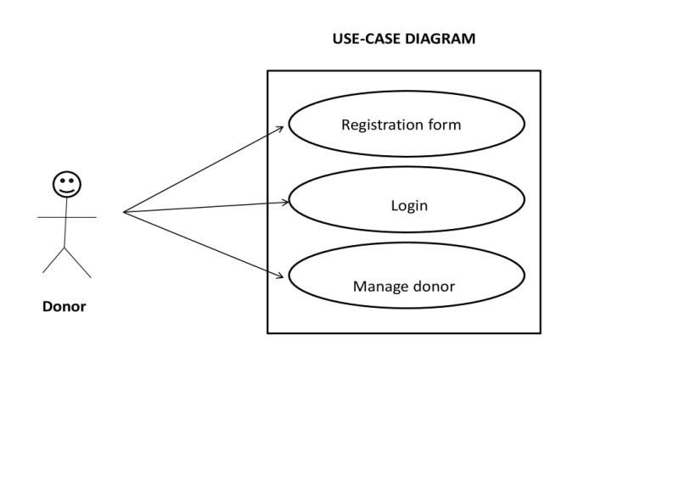

Figure 1- Use case diagram of admin

## ADMIN

The Admin section contains all edits like manage blood bank, manage donor, manage request. He can also change donor details, delete donor or change password. There is also one additional feature of admin panel and that is status button. The Status button is used to hide or delete the status of blood bank. If blood bank is facing some technical issue so admin can hide the blood bank from database for some time. So that user don’t get confused. After the problem solved the admin can easily enable the status button.

* Manage blood request
* Manage blood donor
* Manage blood bank
* Delete donor details
* Admin maintains security of the system
* Logout

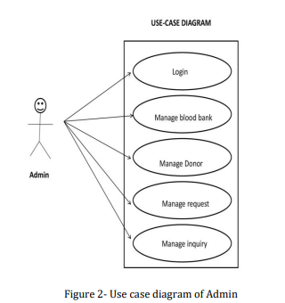

**3.3 Receiver**

The receiver module helps user to find blood group. When user (receiver) click on find a blood group system ask him to enter blood group he want to search. After entering the blood group, system search for the availability of the blood group and give him the list of the blood banks where the blood is available.

The user will select a suitable blood bank and will issue blood.

• Find a donor

• Refer a friend via social media app

• Find a blood group

• Logout

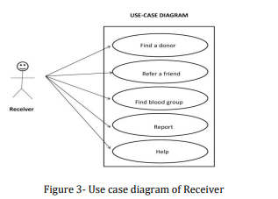

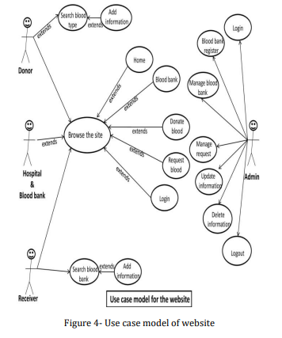

# 4.Outputs

* Admin Page

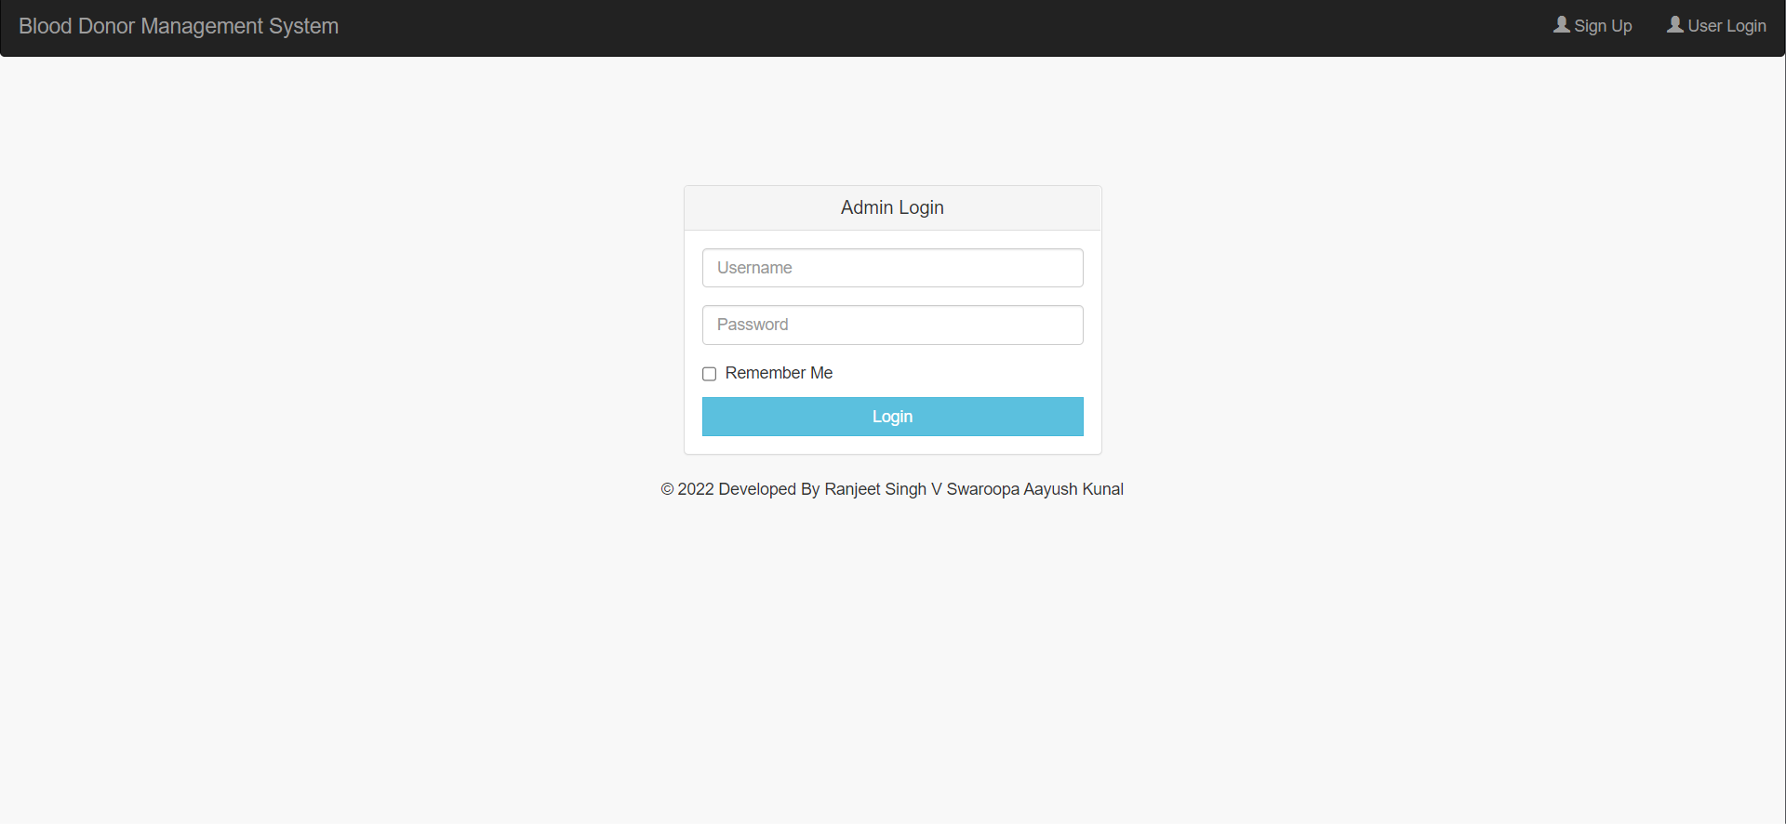

* Register Page

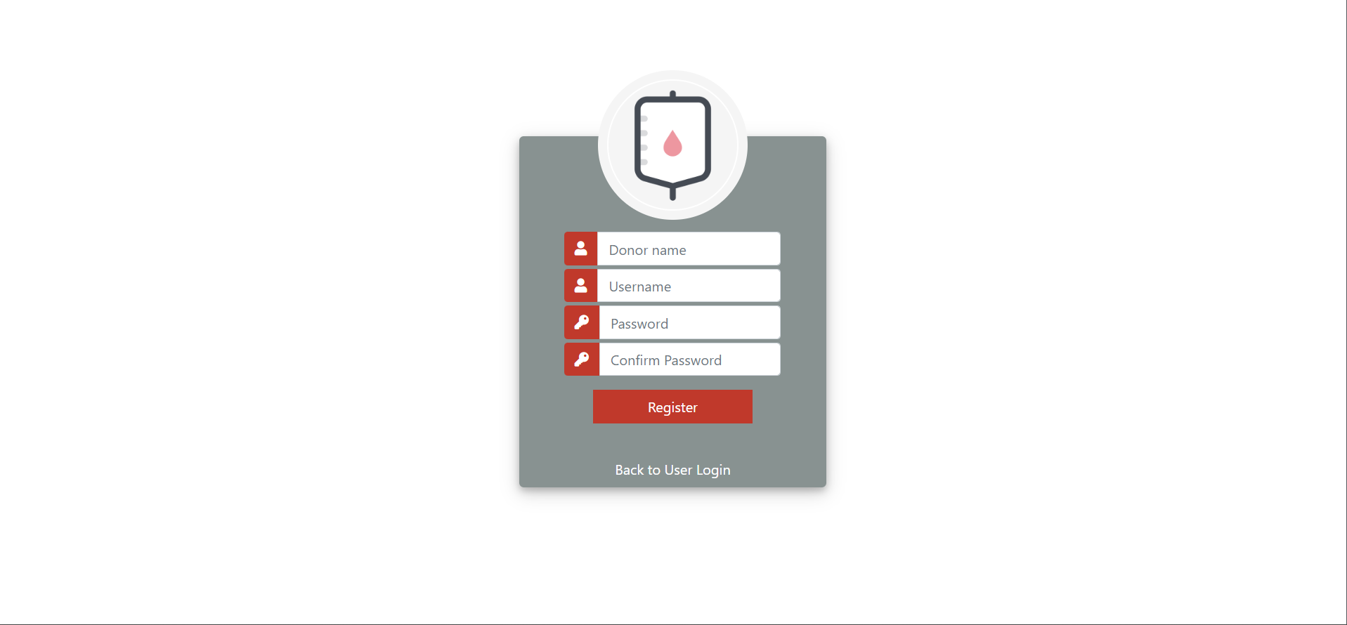

* User Login



* Admin Dashboard

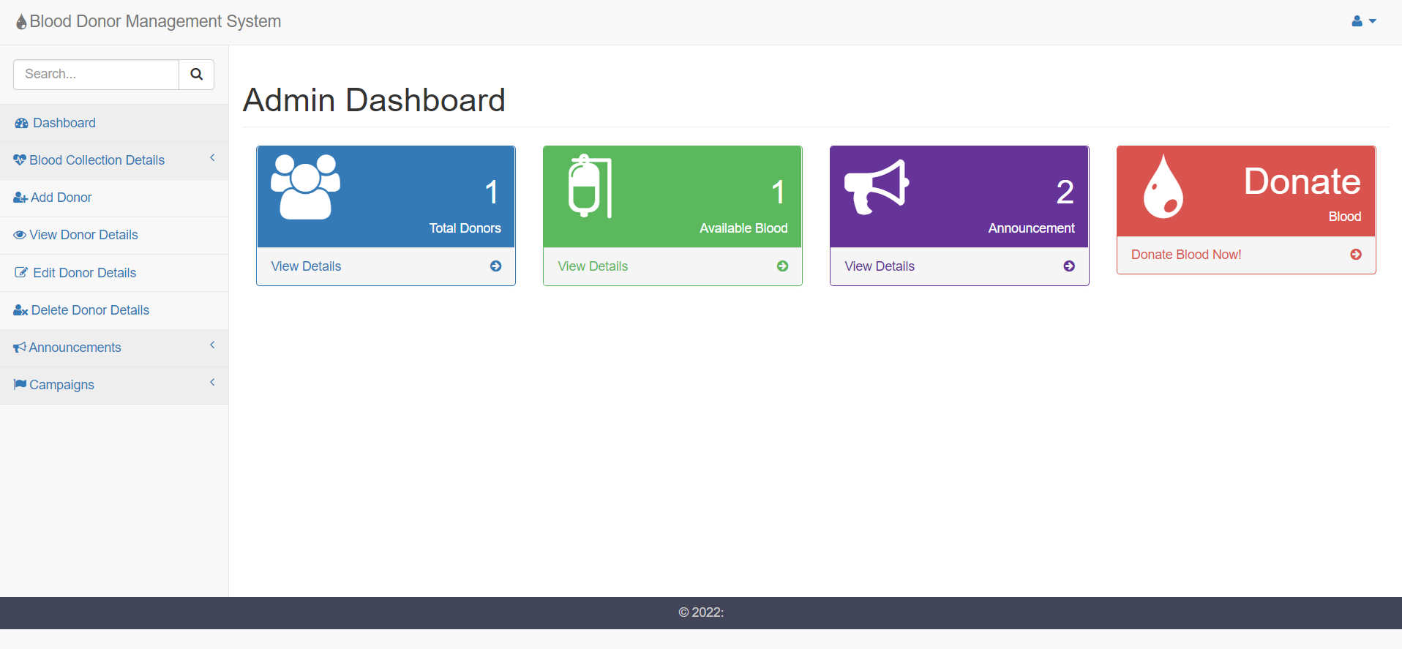

* Add Donor Details

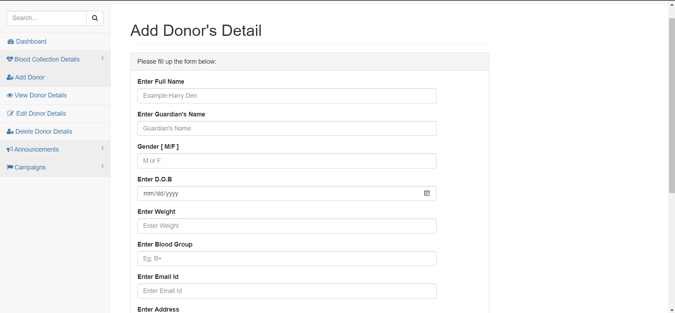

* Donors Dashboard

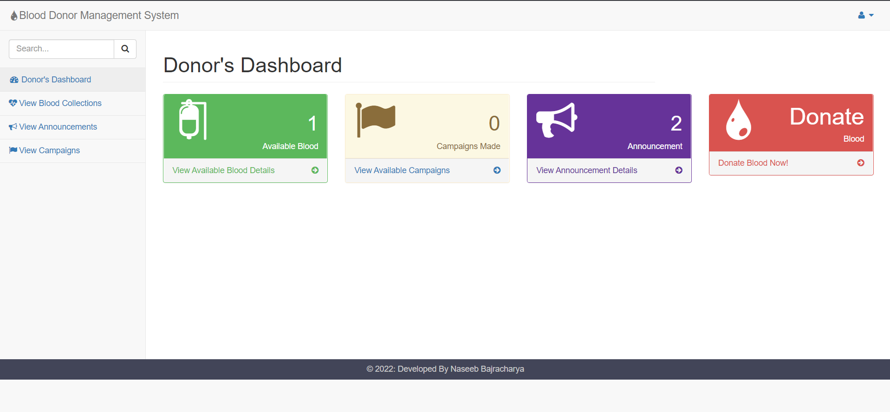

* Blood Collection

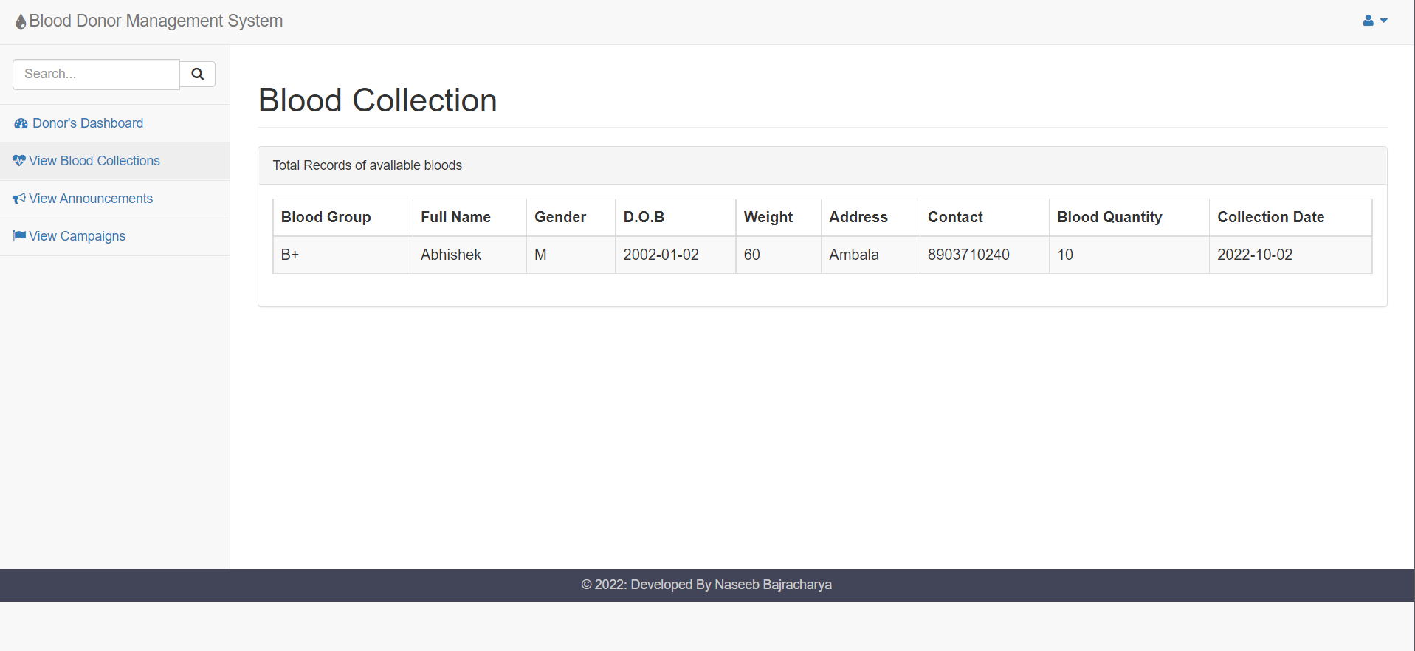

* Announcement Detail

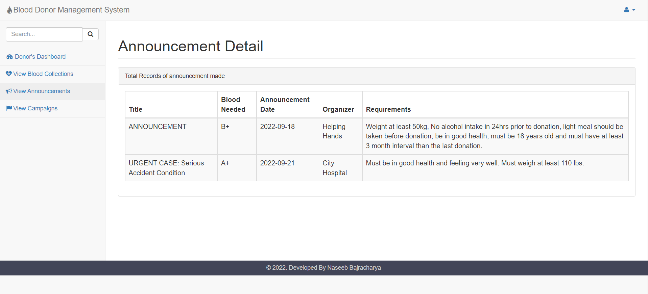

* Edit Blood Details

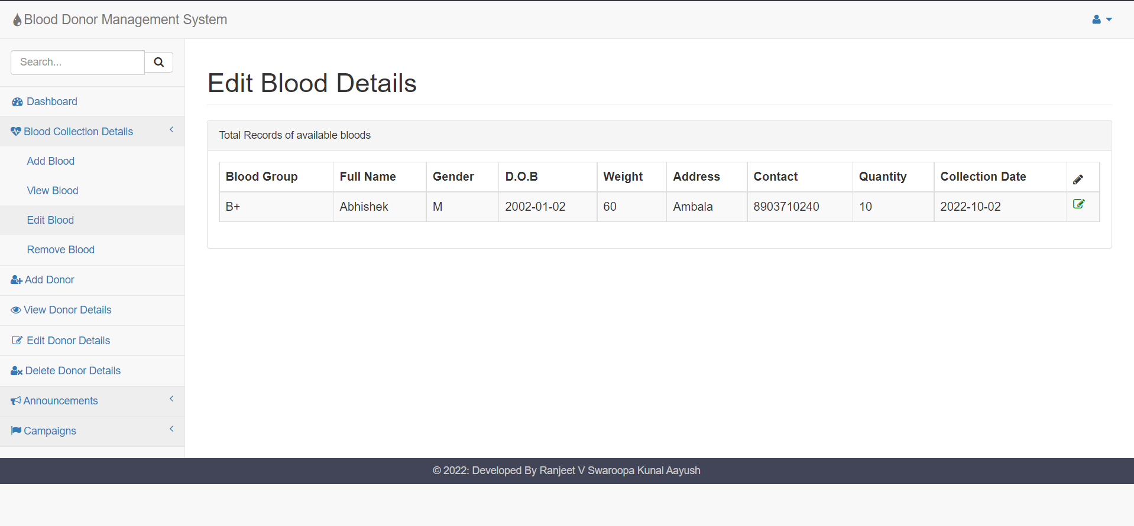

**4. CONCLUSIONS**

Blood banking management system considered to be one of the useful source and need for saving people at emergency . Compared to the paper work method for blood banking this online blood banking management is efficient, time saving , more productivity, more reliable and cost effective. While making the project we tried to focus on the problems that can be solved by this project. As compared to manual system , online based banking security comparatively more secure and accurate in means of data which can further can retrieved easily.

REFERENCES

[1] Blood donor selection Guidelines on assessing donor suitability for blood donation. Annex 3. Geneva: World Health Organization:2012[17 August 2012]

[2] Teena, C.A, Sankar, K. and Kannan, S. (2014). A Study on Blood Bank Management

[3] Kumar, R., Singh, S. and Ragavi, V.A.(2017). ). Blood Bank Management System.

[4] Vikas Kulshreshtha, Dr. Sharad Maheshwari, “Blood Bank Management Information System in India”, International Journal of Engineering Research and Applications (IJERA), Vol. I, Issue.

[5] Alexander Horsch and Thomas Balbach," Telemedical Information Systems", IEEE Transactions On Information Technology In Biomedicine, Vol. 3, NO. 3, September 1999

[6] http://www.naco.gov.in/blood-transfusion-services